|  |
| --- |
| **Software Engineering Project, Boston University**   * Abdul Wasay * Emily Wu * Michael McMahon * Sowmya Shri Sudarshan * Wang Yu * Yasemin Asan |

|  |
| --- |
| CS 673 Group 1 |
| Software Project Management Plan |
| Home-o-Poly : A web based Real estate Application |

1. **Abstract**

This is the project management plan for the Home-O-Poly software engineering group project at MET College, Boston University. This document complies with the IEEE standards for SPMP set by IEEE. The SPMP guides the group leader or the project manager to organize and plan the execution of the project and to manage various role-leaders. This document also anticipates various risks and risk management strategies that can be used to mitigate them.

1. **Table of Contents**
2. Abstract………………………………………………………………………………………………………..... 1
3. Table of Contents…………………………………………………………………………………………….. 2
4. Evolution………………………………………………………………………………………………………… 3
5. Introduction…………………………………………………………………………………………………… 4
   1. Project Overview
   2. Project Deliverables
   3. References
   4. Definitions and Acronyms
6. Project Organization…………………………………………………………………………………….…... 6
   1. Process Model
   2. Organizational Model
   3. Organizational boundaries
   4. Project responsibilities
7. Managerial Process…………………………………………………………………………………………… 10
   1. Management Objectives and priorities
   2. Assumptions, Dependencies and constraints
   3. Risk Management
   4. Monitoring and controlling Mechanism
   5. Staffing Plan
8. Technical Process……………………………………………………………………………………………… 13
   1. Methods, tools and techniques
   2. Software documentation
   3. Project support function
9. Work Packages and Schedule………………………………………………………………………………. 14
   1. Work packages
   2. Dependencies
   3. Resource allocations and requirements
   4. Schedule
10. Additional Components
    1. Index
    2. Appendices
11. **SPMP Evolution**

|  |  |  |  |
| --- | --- | --- | --- |
| Version | Primary Author | Description | Date |
| 1.0 | Abdul Wasay | Initial Draft created for distribution and review | 2-11-2013 |
|  |  |  |  |
|  |  |  |  |

1. **Introduction**

This section describes the project with special emphasis on motivation, objectives and deliverables of the project.

* 1. **Project Overview**

The project is a web based application that will be written in PHP with a MySQL database at the backend. There are two type of users who would interact with the application- a buyer- who initiates a request from the house, the seller - who authorizes the purchase of the house, he/she or the agent are also manager that can review the status of their houses. We propose to create the application with the functionality mentioned in the requirements section below, and we named this real estate web application Home-O-Poly.

* 1. **Project Deliverables**
     1. **Functional Requirements**

The project aims to achieve the following functional requirements:

* Provide a user the ability to create account
* Provide a registered user to enter/update the information about a property.
* Provide a registered as well as unregistered user to search for a property based on his/her preference.
* Provide an interactive user interface for scrolling through the database.
* Prompt a registered user if a property based on his/her requirement shows up.
* Have an interface for the admin to validate/modify information
* Ability to compare and rate properties
  + 1. **Non-Functional Requirements**
* **Data Base:**

Have a backend database for storage and retrieval.

* **Communication:**

Have an E-mail server for communication with the clients.

* **Deployment:**

Have web hosting for the website.

* **Testability:**

Could be tested by using simple but comprehensive test cases

* **Platform Compatibility:**

Should be able to run in all HTML5 compatible browsers.

* **Security:**

The personal information provided should be kept secure.

* 1. **References**

IEE Template adapted from: http://users.csc.calpoly.edu/~jdalbey/205/Mgmt/SPMP.html

* 1. **Definitions and Acronyms**

BU- Boston University

SQAP- Software Quality Assurance Plan

MET- Metropolitan College, Boston University

HTML- Hypertext Markup Language

1. **Project Organization**
   1. **Process Model**

This project employs the spiral model with rapid prototyping to minimize risks at each prototype. Iteration will last for 3 weeks and the result produced towards the end will be tested and finalized. Code Reviews will be done frequently in groups to minimize risk of large number of bugs towards the end.

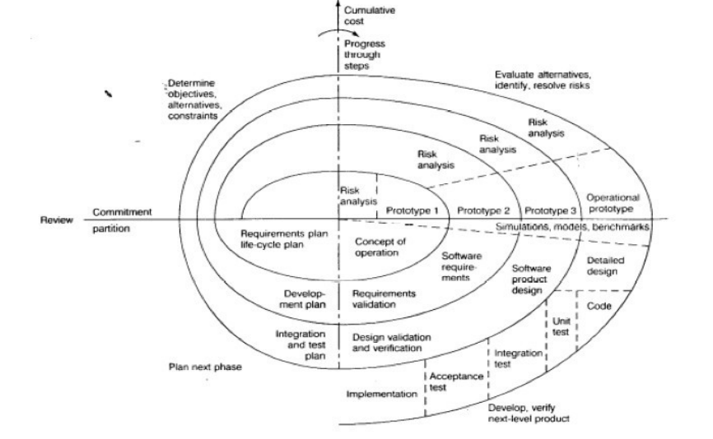

Adapted from: http://courses.cs.vt.edu/csonline/SE/Lessons/Spiral/spiralmodel.html

The table below outlines the various tasks to be completed in each of the iterations:

|  |  |  |  |
| --- | --- | --- | --- |
| Iteration | Status of the project | Deliverables | Remarks |
| 1 | complete planning project with decided deliverables and requirements | Project Proposal  SQAP  SPMP  Working Interface  Design of the database |  |
| 2 | A working prototype of the final project with less focus on aesthetics and scalability having minimal features | Working database  Working interface  Responsive server-side  At least one code review  Partial testing |  |
| 3 | A complete project with all the agreed features | Completely tested for scalability and persistence  Multiple code reviews done  A complete web application |  |

* 1. **Organizational Structure**

As the project is being done as a part of a software engineering course, no role of customer is assigned as yet. However, a hierarchical organizational structure is followed where the project Manager or the group leader is assisted by other role specific leaders. It should also be mentioned that as this is purely an academic activity, every member of the group participate equally in all areas of the software engineering process however, the role leaders monitor activities specific to their assigned area.

* 1. **Project Responsibilities**
     1. **Group Leader**

The roles of the group leader include all of the followings:

* + Team co-ordination and communication
  + Organization of meetings and their agenda
  + Risk prediction and management
  + Task allocation and discussion
  + Documentation handling and supervision
  + Informing the team of and keeping track of the deadlines
    1. **Configuration Leader**

The roles performed are as under:

* Decide and manage the code repository
* Upload and organize the code base
* Co-ordinate any related activity
  + 1. **Environment and integration leader**

The roles performed are as under:

* Decide and manage the IDE to be used for development
* Work closely with all members of the team who are involved in the implementation
* Co-ordinate code reviews
* Co-ordinate integration of various code components and debugging
* Integration of the interface (HTML) with the Database and the logic (PHP)

**2.3.4. Requirement Leader**

The roles performed are as under:

* Organize and manage the pivotal tracker
* Discuss and decide the various functional and non-functional requirements of the project.
* Co-ordinate and work closely with the implementation team

**2.3.5. Design Leader**

The roles performed are as under:

* Database design
* Website/webpage design
* Work closely with the implementation team to ensure the design is followed
* Provide ER and other diagrams to make understanding design easy for other members of the team.

**2.3.6. Implementation Leader**

The roles performed are as under:

* Organize and manage the entire group as they implement the various components of the project.
* Provide support to members of the group who are relatively new to the technology
* Organize and co-ordinate code reviews.
* Ensure that Risks related to software implementation are minimized

**2.3.7. Testing Leader**

The roles performed are as under:

* Brainstorm for test case in a group
* Organize and manage test case coding
* Organize through testing of the prototype as well as the finalized product to minimize risks at each step
* Ensure Quality of code and design throughout the project

**2.3.8. Documentation Leader**

The roles performed are as under:

* Manage the documentation of the entire project including managerial documents and technical docs.
* Work closely with the implementation team
* Update the status of the docs periodically.

1. **Managerial Process**

This part of the document highlight the various strategies employed in management, risk assessment and management, dependencies and constraints as well as the managerial model to be followed during the course of this project.

**3.1. Management Objectives and Priorities**

As stated above, this project is done as a part of an academic course. Therefore, the top most priorities of the management and the team is to acquire as much understanding and experience of the software engineering process as possible while maintaining the standards of a world class software development team. Quality of the end product and strict adherence to deadlines are amongst the top priorities of the team and will be enforced at each of the iterations.

**3.2. Assumptions, Dependencies and Constraints**

Due to the academic nature of the project, the role of the customer is being played by the instructor. She will monitor and provide feedback during the course of the project and will test the prototypes. Also, it should be mentioned that owing to temporal constraints, the features of the web application are limited to the ones described above.

* 1. **Risk Management Strategies**

**3.3.1. Risk Identification**

It is amongst the duties of the various role leaders and the group leader to identify and document the risks associated with their specific tasks periodically. Also, weekly meetings will include a comprehensive risk analysis and brainstorming sessions to identify risks before they are encountered.

* + 1. **Risk Minimization Strategies**

The team is employing various strategies to mitigate the risk before it occurs and to ensure quality. They include but are not limited to:

* Weekly meetings with intensive brainstorming sessions
* Rapid prototyping following the spiral model to mitigate the effects of risks on the project
* Extensive usage of the pivotal tracker to track progress and risks associated with each of the tasks at various stages.
* Documentation and code repository management

**3.4. Monitoring and Controlling Mechanism**

The pivotal tracker is used as a tracking tool for managing the software development process and enforcing quality and deadline adherence. Also various strategies are being applied to facilitate the process for the entire team as described below.

* Weekly Meetings:

Every Friday, a meeting of approximately an hour is scheduled to discuss last week’s progress and the tasks of the upcoming one.

* Meeting Minutes

Minutes are recorded and documented every week.

* Weekly tasks allocation

Tasks are allocated weekly to the team members and are monitored through the pivotal tracker.

* Online Interaction:

Online tools like Google groups, E-mails and Skype are used as means of communication between group members to facilitate decision making and management

* Presentation and brainstorming;

Each iteration comes with a presentation to inform the entire class about th progress, challenges and future plans regarding the project.

* Google Docs sharing;

Google Drive folder is used to share various documents like the SQAP, SPMP, ER diagrams amongst the group members.

* 1. **Staffing Plan**

For the completion of the project a group of 6 people are required and so far the team has all the required individuals. The require skills include familiarity with web development, good managerial skills and a willingness to learn and adapt.

|  |  |  |
| --- | --- | --- |
| Sr. No | Names | Roles |
| 1 | Abdul Wasay | Group Leader |
| 2 | Emily Wu | Documentation Leader, Design Leader |
| 3 | Michael McMahon | Back-up group Leader, Implementation Leader |
| 4 | Sowmya Shri Sudarshan | Testing Leader, Requirement Leader |
| 5 | Wang Yu | Design and implementation Leader |
| 6 | Yasemin Asan | Environment Leader, Integration Leader |

1. **Technical Process**

This part of the document deals with the technical aspects of the project. It outlines the technology, software, platform and hardware to be employed in the course of the software development.

* 1. **Method, Tools and Techniques**

It has been decided that the project team will employ the Dreamweaver IDE for coding in HTML, PHP and CSS. As this software is available across all platforms and operating system, the operating system becomes inconsequential. Most of the team members are using their personal laptops that are installed with either Windows or Mac OS.

The programming methodology we are planning to employ involves developing the HTML interface and design separately from the Logic and having a background database for storage. Also, through commenting is done while coding to make the code descriptive and understandable for code review.

For the purpose of code review, bi-monthly meetings will be organized. During these meetings, the team can be divided in two groups who can review the code twice sequentially to minimize errors and ensure comprehensive review.

* 1. **Software Documentation**

The various documents which will be developed for the project and their status are presented below:

|  |  |
| --- | --- |
| Name of Doc | Status |
| Project Proposal | Ready to be submitted |
| SQAP | Live Document, First draft ready |
| SPMP | Live Document, First draft ready |
| Meeting Minutes | Weekly submission |
| ER Diagrams | Ready and available on the Google Drive |